Homework Assignment 3

Name: Asrar Syed
Due by: March 08, 2025
Course Section: CSC 4320-034

- (5 points) Write down the Amdahl’s law and describe its parameters. Using Amdahl’s Law, calculate the speedup gain of an application that has a 90 percent parallel with four and eight processing cores.

$$Speedup≤\frac{1}{S+\left(\frac{1-S}{n}\right)}$$
Parameter Key:
$Speedup or S(n)$ = The theoretical maximum possible speedup with n processors
$S$ = The portion of the program that is serial (i.e., cannot be parallelized, limits speedup)
$1-S$ = The fraction of the total execution time that can be parallelized
$n$ = Number of available processors

- four processing cores
$$Speedup=S\left(4\right)≤\frac{1}{.1+\left(\frac{0.9}{4}\right)}=\frac{1}{\frac{1.3}{4}}=\frac{4}{1.3}=3.07692=3.08$$
- eight processing cores.
$$Speedup=S\left(8\right)≤\frac{1}{.1+\left(\frac{0.9}{8}\right)}=\frac{1}{\frac{1.7}{8}}=\frac{8}{1.7}=4.70588=4.71$$

- What (if any) relation holds between the following pairs of algorithm sets?

    - (2 points) Priority and SJF

Similarity: SJF is a special case of Priority Scheduling where priority is determined by burst time (shorter jobs have higher priority).

Difference: In Priority Scheduling, priorities can be assigned arbitrarily (not necessarily based on burst time).

    - (2 points) Multilevel feedback queues (MLFQ) and FCFS

Similarity: The lowest-level queue in MLFQ often uses FCFS, meaning long-running processes eventually get scheduled in FCFS order.

Difference: MLFQ dynamically adjusts a process's priority, while FCFS always follows arrival order without adjustment.

    - (2 points) Priority and FCFS

Similarity: If all processes have the same priority, Priority Scheduling behaves exactly like FCFS.

Difference: Priority Scheduling allows high-priority processes to preempt others, while FCFS does not.

    - (2 points) RR and SJF

Similarity: If RR time slices are very small and the job lengths vary, shorter jobs may finish quickly, making RR behave somewhat like SJF.

Difference: RR enforces time fairness, while SJF focuses on minimizing the waiting time by always picking the shortest job first.

- Consider the following code segment:

Step One:
pid_t pid;
pid = fork();

Step Two:
if (pid == 0) { /* child process */
fork();
thread_create(...);
}

Step Three:
fork();

We can explain this code by breaking it down into the 3 steps shown above.

In step one we start with our initial process (P0) and the create a new child process (P1).
This leaves us with two processes: P0 (parent) and P1 (child).

In step two we are inside an if-block that the child process (P1) executes. We create another child process (P2) using the fork() command and the thread_create(...) command creates one new thread in (P1).
This leaves us with three processes P0, P1, and P2. We also have one unique thread in P1.

In step three the fork() command is executed by all 3 existing processes, doubling the number of processes.
Now, we have six processes (P0, P1, P2, P3, P4, P5).

- (5 points) How many unique processes are created? Explain in detail.

Disregarding the initial process referred to as P0 we created 5 unique process (P1, P2, P3, P4, P5).

- (5 points) How many unique threads are created? Explain in detail.

The only thread_create(...) is inside P1, meaning only P1 creates one additional thread.

- (6 points) Consider the following program using Pthreads API

#include <pthread.h>
#include <stdio.h>

int value = 0; /* this data is shared by the thread(s) */
void * runner(void * param); /* the threads call this function */

int main(int argc, char * argv[]) {
pid_t pid;
pthread_t tid; /* the thread identifier */
pthread_attr_t attr; /* set of thread attributes */
pid = fork();
if (pid == 0) { /* child process */
pthread_attr_init( &attr); /* set the default attributes of the thread */
pthread_create( &tid, &attr, runner, NULL); /* create the thread */
pthread_join(tid, NULL); /* wait for the thread to exit */
printf("CHILD: value = %d", value); /* LINE C */
}
else if (pid > 0) { /* parent process */
wait(NULL);
printf("PARENT: value = %d", value); /* LINE P */
}
}
/* The thread will execute in this function */
void * runner(void * param) {
value = 5;
pthread_exit(0);
}

Describe what is happening in the program. What would be the output from the program at LINE C and LINE P?

The program starts executing at main(), where:
- The global integer variable value is initialized to 0.
- A process is created using fork(), which creates a child process that is a copy of the parent process. The pid variable is then used to differentiate between the parent and child process.

Continuing inside the if-block code executed by the child process:
- The child process initializes thread attributes using pthread_attr_init() and then creates a thread that executes the runner() function. Inside runner(), the global value is set to 5, and the thread exits. The child process waits for the thread to complete using pthread_join().
- After the thread execution, value should be 5, and it prints "CHILD: value = 5" at LINE C.

Continuing inside the else-block code executed by the parent process:
- The parent process waits for the child process to finish using wait(NULL).
- After the child process terminates, it prints "PARENT: value = 0" at LINE P.

- Consider the following set of processes, with the length of the CPU burst time given in milliseconds:

Process | Burst Time | Priority
P1 | 5 | 4
P2 | 3 | 1
P3 | 1 | 2
P4 | 7 | 2
P5 | 4 | 3

The processes are assumed to have arrived in the order P1, P2, P3, P4, P5, all at time 0.

- (4 points) Draw four Gantt charts that illustrate the execution of these processes using the following scheduling algorithms: FCFS, SJF, non-preemptive priority (a larger priority number implies a higher priority), and RR (quantum = 2).

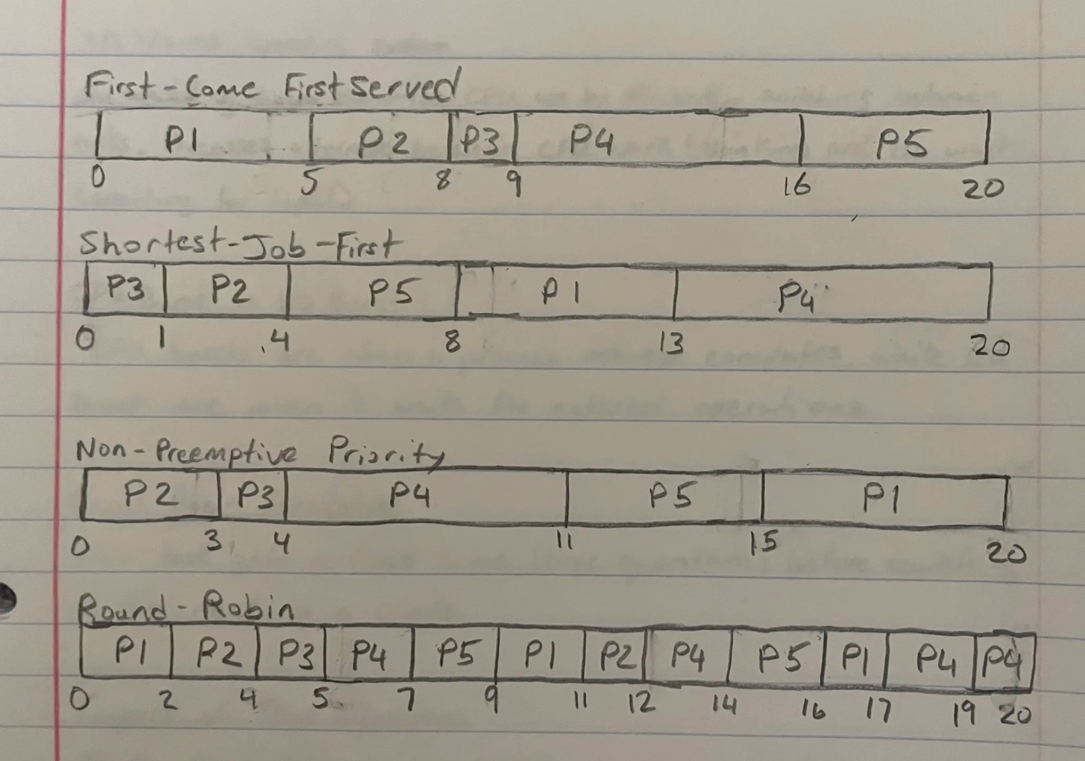

- (4 points) What is the turnaround time of each process for each of the scheduling algorithms in part a?

First-Come First Served: Average turnaround time: (5 + 8 + 9 + 16 + 20)/5 = 11.6 ms

Shortest-Job-First: Average turnaround time: (1 + 4 + 8 + 13 + 20)/5 = 9.2 ms

Non-Preemptive Priority: Average turnaround time: (3 + 4 + 11 + 15 + 20)/5 = 10.6 ms

Round Robin: Average turnaround time: (17 + 12 + 5 + 20 + 16)/5 = 14 ms

- (4 points) What is the waiting time of each process for each of these scheduling algorithms?

First-Come First Served:
Waiting time for P1 = 0; P2 = 5; P3 = 8; P4 = 9; P5 = 16
Average waiting time: (0 + 5 + 8 + 9 + 16)/5 = 7.6 ms

Shortest-Job-First:
Waiting time for P1 = 0; P2 = 1; P3 = 4; P4 = 8; P5 = 13
Average waiting time: (0 + 1 + 4 + 8 + 13)/5 = 5.2 ms

Non-Preemptive Priority:
Waiting time for P1 = 0; P2 = 3; P3 =4; P4 =11; P5 = 15
Average waiting time: (0 + 3 + 4 + 11 + 15)/5 = 6.6 ms

Round Robin:
Waiting time for P1 = 12; P2 = 9; P3 = 4; P4 = 13; P5 = 12
Average waiting time: (12 + 9 + 4 + 13 + 12)/5 = 10 ms

- (4 points) Which of the algorithms results in the minimum average waiting time (over all processes)?
The algorithm that results in the minimum average waiting time over all processes is SJF.
- Consider two processes, P1 and P2,where p1 = 50, t1 = 25, p2 = 75, and t2 = 30.

Processes: P1 and P2
Periods: p1 = 50 and p2 = 75
Processing Times: t1 = 25 and t2 = 30

P1 is assigned a higher priority than P2.

- (2 1/2 points) Can these two processes be scheduled using rate-monotonic scheduling? Illustrate your answer using a Gantt chart.

The total CPU utilization for two tasks in RMS must satisfy: $U=\sum{\frac{ti}{pi}}≤n\left(2^{\frac{1}{n}}-1\right)$

For n = 2, the bound is: $U≤2\left(2^{\frac{1}{2}}-1\right)=0.828$

Calculating the utilization: $U=\frac{t1}{p1}+\frac{t2}{p2}=\frac{25}{50}+\frac{30}{75}=0.5+0.4=0.9$

Since 0.9 > 0.828, the system fails the RMS utilization bound, meaning the processes cannot be scheduled using rate-monotonic scheduling as one of the processes will miss their deadline.

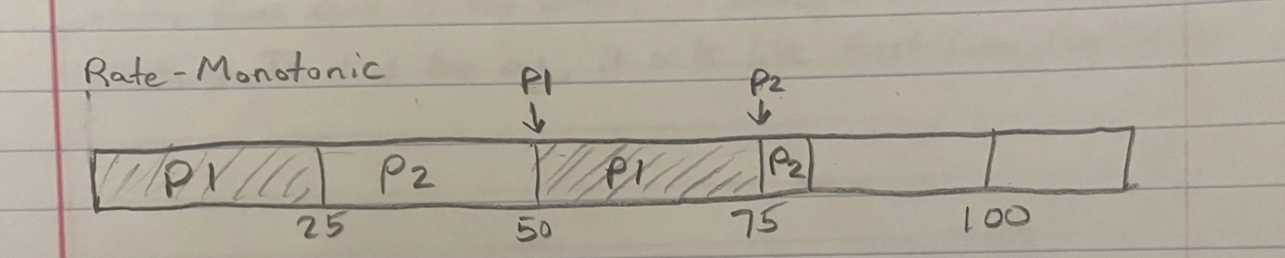

P1 executes first because it has a higher priority, every 50 ms. P2 runs only when P1 is not executing. P2 misses its deadline at t = 75 because it needs 30 ms, but only 25 ms is available.

- (2 1/2 points) Illustrate the scheduling of these two processes using earliest-deadline-first (EDF) scheduling.

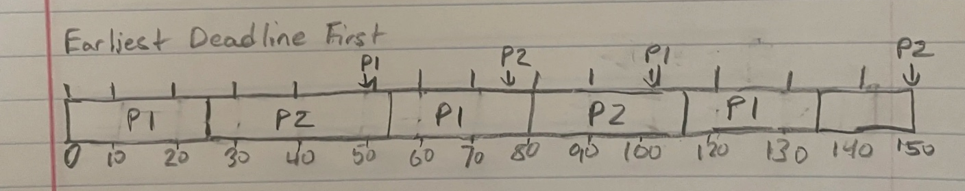

- 5 points) Consider a system running ten I/O-bound tasks and one CPU-bound task. Assume that the I/O-bound tasks issue an I/O operation once for every millisecond of CPU computing and that each I/O operation takes 10 milliseconds to complete. Also assume that the context-switching overhead is 0.1 millisecond and that all processes are long-running tasks. Describe the CPU utilization for a round-robin scheduler when the time quantum is 10 milliseconds.

Summarizing the Given Information:
10 I/O-bound tasks: Each requires 1 ms of CPU time before issuing an I/O request that takes 10 ms.
1 CPU-bound task: Continuously needs CPU time.
Context switch overhead: 0.1 milliseconds.
Time quantum: 10 milliseconds.

Understanding the Execution Process:

For each I/O-bound task, the task runs for 1 ms of CPU time then initiates a I/O and blocks. The context switch occurs for 0.1 ms and the next task begins.

For the CPU-bound task, the task runs for full 10ms time quantum and the context switch occurs (0.1ms) right after. The next task can begin after those two occur.

Calculating Total Time and CPU Usage:
For 10 I/O-bound tasks: 10 * 1ms CPU + 0.1ms context switch) = 11ms
For 1 CPU-bound task: 10ms CPU + 0.1ms context switch = 10.1ms

The total cycle time: 11ms + 10.1ms = 21.1ms

The total productive CPU time: 10 * 1ms + 10ms = 20ms
Total context switching overhead: 11 * 0.1ms = 1.1ms

So the CPU utilization can be found by dividing the Productive CPU time by the Total time.

CPU utilization = 20ms / 21.1ms ≈ 94.8%

